Michael Skeats
Design and Development Document

Object oriented principles
While developing my Zoo management program I demonstrated the principles of Encapsulation, Inheritance, Polymorphism and Abstraction. Encapsulation is a programming concept that combines Attributes and methods to control access to the data ensuring data integrity is maintained. This principle was showcased in my Animal class where I used public getter and setter methods to control access and validate any inputs to private attributes such as name, age, colour and weight. Inheritance is when a subclass inherits existing fields and methods from an existing parent class. This principle is shown through the three subclasses of animal that were created being Lion, Dove and Goose with each of these subclasses inheriting attributes from animal while each having their own unique attribute. Polymorphism in object-orientated programming refers to being able to store different objects as the same place while acting differently whenever a method is called. Polymorphism is utilised in three places in my program the array list Animal which stores all animals regardless of type, in the make sound function as each subclass overrides the function thus giving their own version of the function and in the interfaces, I used which allow multiple subclasses different subclasses to implement different behaviours. Lastly, abstraction is the process of hiding implementation details while only exposing essential features. This was achieved through the abstract class animal and interfaces which only define behaviours and not the details of the implementation.

UML Diagram
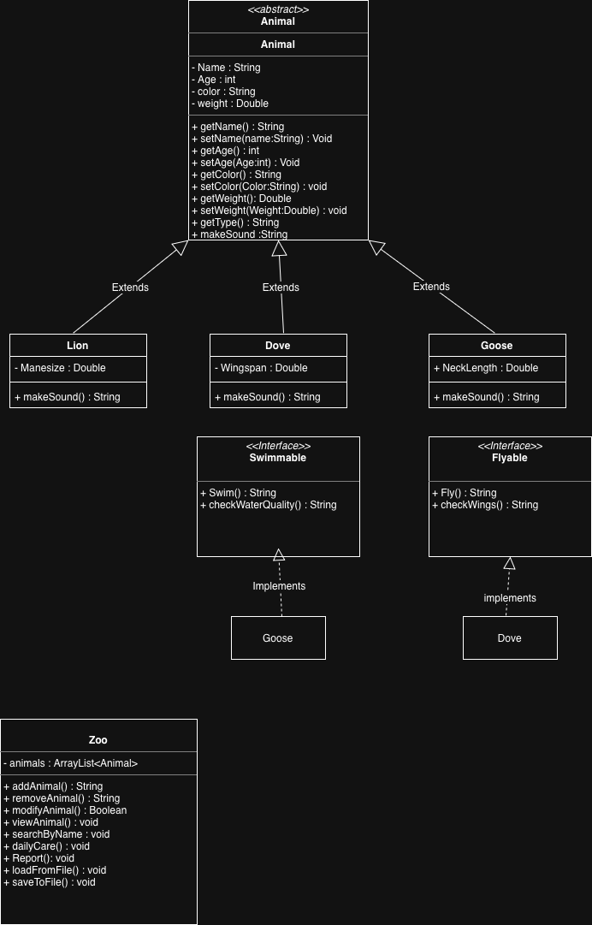
Inheritance Hierarchy design
The application uses a single inheritance hierarchy centred around the abstract class animal which acts like the base class that defines the common attributes such as name, age, colour, weight shared by all attributes alongside the getter and setter method and the make sound function which must be implemented by all subclasses. Subclasses such as Lion, Dove and Goose extend from the animal class using inheritance which allows them to reuse common attributes and methods defined in the animal class while also introducing subclass specific attributes. Each subclass overrides the make sound method showing that behaviour can differ between animal types while maintaining a consistent structure therefore my program supports polymorphism as all animals are treated the same but act differently at runtime. The design of the program supports scalability as new animal types can be added easily by creating a new class that extends from animal alongside any required methods.

In conclusion, the inheritance hierarchy reduces code duplication and allows for new animal types/ features to be easily added as needed.

Data and Control Structures
The main data structure utilised in this project is an Arraylist. I chose to use a Arraylist because it allows for dynamic storage of objects meaning that animals can be added and removed easily alongside not having a fixed size making it key to the functionality of my program. Additionally, it shows polymorphism as arraylists can store the different subclasses of animal in the same collection. If/Else statements were utilised to validate user inputs such as checking if fields were filled in an alerting user when they weren’t filled in. Additionally, these loops were used to check behaviour using Instanceof to check whether an animal is swimmable or flyable. If/Else statements improve the reliability of the programs data. Loops were used to iterate through the array list thus allowing for the program to access each animal object allowing operations such as displaying reports and displaying each animal. Switch statements were used to create the menu system and type selection menu due to it allows for easy maintenance and scalability as new functions can be added easily.

